**Phase 1 Deliverables from GenAI backend team**

30 August 2025

**Phase 1 Deliverables Documentation**

**Project**: AI-Powered Budget Optimizer for Trip Plans

**Phase Duration**: 3–4 Weeks

**1. Project Overview**

Phase 1 includes the below approach for budget optimization based on users input.

User provides the following information in the chatbot:

* Origin & destination(s)
* Budget constraints
* Number of days
* Preferred activities/interests

The application integrates multiple APIs and AI models to:

1. Search and recommend places to visit (via Perplexity Search API).
2. Optimize itinerary using Azure OpenAI LLM for structured outputs.
3. Display place with coordinates, names, and routes using Google Places API.
4. Support developers with GitHub Copilot for faster development.

**2. Tech Stack**

* Backend: Python
* AI/LLM: Azure OpenAI models (GPT-4o global standard)
* Search & Reasoning: Perplexity API (Sonar reasoning model)
* APIs:
  + Google Places API (Nearby Search, Place Details, Photos, Directions, Static Map API for frontend visualization)
* Development Assistance: GitHub Copilot 2

**3. Architecture (High-Level Flow)**

1. User Input: Source, destination(s), number of days, budget, interests.
2. Search & Retrieval:
   * Perplexity API → fetches curated destination insights.
   * Google Places API → retrieves nearby attractions, details, photos, directions.
3. AI Processing:
   * Azure OpenAI LLM → structures itinerary, budget optimization, personalized recommendations.
4. Backend Processing:
5. Frontend Output:
   * Map & route visualization (Google Maps Static API).
   * Budget-optimized itinerary presented to the user.

**4. Phase 1 Deliverables**

1. System Setup & Integration
   * API integrations (Google Places API, Perplexity API).
   * Azure OpenAI GPT-4o integration.
2. Core Features (MVP)
   * Accept user inputs (origin, destination, budget, days).
   * Retrieve destination data (via Perplexity + Google Places).
   * Generate structured itinerary with budget optimization.
   * Display locations and routes on static map.
3. Documentation
   * Tech stack documentation.
   * API usage with pricing references.
   * Cost estimates.

**5. Cost Estimates (Phase 1)**

**Azure OpenAI (GPT-4o Standard Pricing)**

* Input: $2.50 per 1M tokens
* Cached Input: $1.25 per 1M tokens
* Output: $10 per 1M tokens  
  📖 [Reference](https://azure.microsoft.com/en-us/pricing/details/cognitive-services/openai-service/)

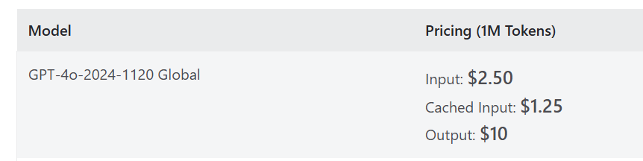

**Perplexity (Sonar Reasoning Model)**

* Input: $1 per 1M tokens
* Output: $1 per 1M tokens
* Sonar Medium Context Reasoning: $8 per 1,000 requests  
  📖 [Reference](https://docs.perplexity.ai/getting-started/pricing)

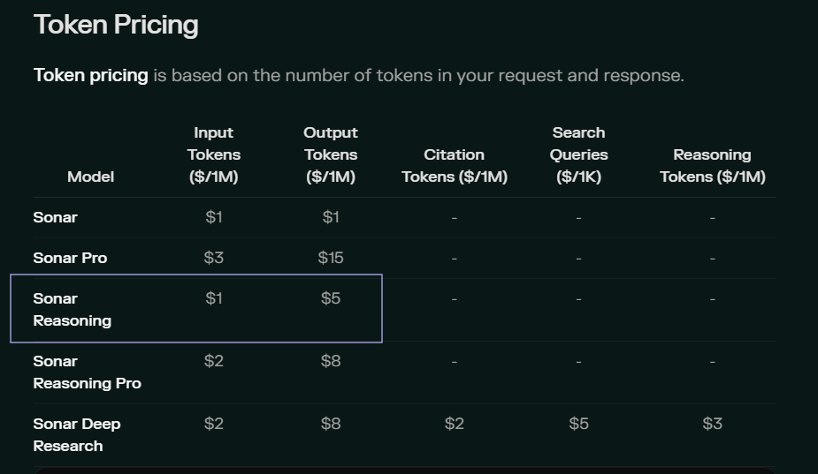

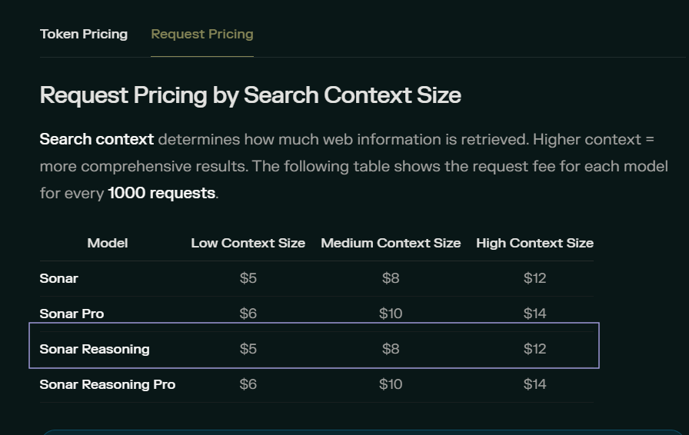

**Google Places API (India Pricing)**

* Maps Embed API → Free (to be validated).
* Places API Text Search Essentials (IDs only): Free / Unlimited.
* Places API Place Details Pro:
  + Up to 5,000,000 requests: $5.10 per 1,000
  + Beyond 5,000,000 requests: $1.28 per 1,000  
    📖 [Reference](https://developers.google.com/maps/billing-and-pricing/pricing-india#places-pricing)

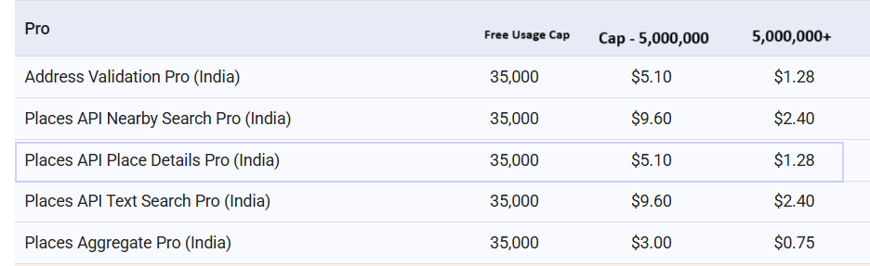

GitHub Copilot

* $10/month per user.  
  📖 [Reference](https://github.com/features/copilot/plans)

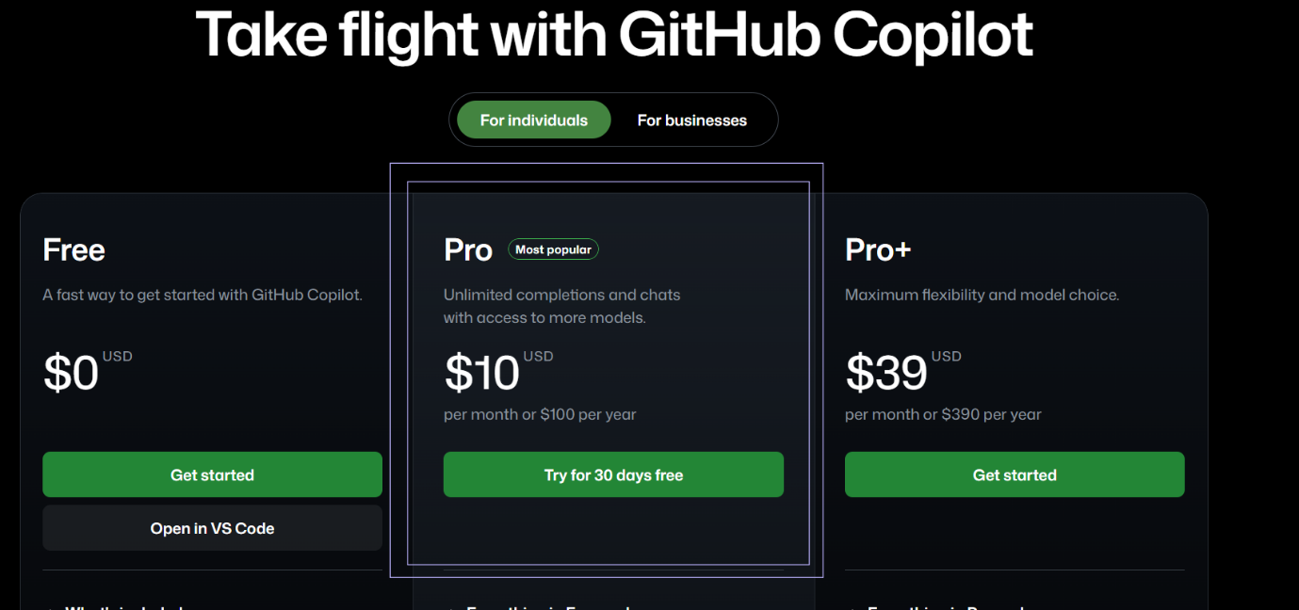

6. Timeline (Phase 1: 3–4 Weeks)

Week 1:

* Create accounts for Azure, Google cloud, perplexity, github copilot
* Setup environment (API credentials). Github infrastructure for AI Agents
* Integrate GitHub Copilot for dev assistance.

Week 2:

* Connect Perplexity API for destination insights.
* Integrate Google Places API for places, routes, static maps.

Week 3:

* Integrate Azure OpenAI GPT-4o for itinerary structuring & budget optimization.
* Develop MVP: Input form → Itinerary + Map output.

Week 4:

* Internal testing, bug fixes.
* Finalize Phase 1 deliverables & documentation.

7. Next Steps (Post-Phase 1)

* Advanced UI/UX for frontend.
* User authentication & personalization.
* More detailed cost simulation for scaling.
* Multi-user concurrency testing.